

**Atfaluna / اطفالنا**



***Phase 01***

**By**

Mohamed Eldesoky

Abdulrahman El-Ghuff

Abedalrahman Rasem

**Supervised By**

Dr. Ammar Odeh

**Submitted in partial fulfillment of the requirements for the degree of**

BACHELOR OF SCIENCE  
**in**

COMPUTER SCIENCE

**at**

PRINCESS SUMAYA UNIVERSITY FOR TECHNOLOGY

Amman, Jordan 2021

**Table of Contents**

**Contents**

Phase 1: Atfaluna Information system report……………………………………………………….4

1.1: Intro to Atfaluna……………………………………………………………………………………………………………5

1.2: System Description………………………………………………………………………………………..6

1.3: System Purpose…………………………………………………………………………………………….7, 8

1.4: Problem Statement……………………………………………………………………………………………………..9

1.5 The System Context view…………………………………………………………………………………………….10

1.6 Literature Review………………………………………………………………………………………………………..11

1.7 Challenges…………………………………………………………………………………………………………………..12

1.8 Projection……………………………………………………………………………………………………………………13

**1.1 – Intro to Atfaluna**

In order for us to rise and face the problems that our current society faces, we must have a good generation capable of building and possessing sufficient awareness to face the events that are going on in our society. Therefore, we will target groups under the age of 18 years to increase their awareness and knowledge of their rights and duties, and one of the most important problems that our current society faces is the lack of sufficient awareness among future generations, so we will create an application that aims to help these groups increase their awareness and educate them, after a referendum of the people A high percentage of Jordanians find problems with delivering their reports to the police , due to the difficulty of communicating with the competent authorities, and we aim through our program to report the problems that they may face smoothly and easily, or to see others confront and correct the direction of the perpetrators of such problems, which leads to the reduction of such events in the future of our society.

**1.2 – System Description**

Users resort to smart phone applications for ease of access and use, so we meet the market and community requirements and use smart phone applications to reach all segments of society as well, so the system will interact with the user to request submitting complaints or to know the rights and duties of the youth of the future. Our application, Atfaluna, will provide the Juvenile Police Department with the necessary information to provide Complaint and dealt with seriously as soon as possible. Since Atfaluna will be accessible to everyone, it is generic, long-term, and easy to use.

**1.3 – System Purpose**

Through our application, we aim to protect future generations, those generations that will lead the country in the coming days and increase their awareness to reach an ethically sound society away from violence and dysfunctional acts, stop child abuse and prevent the employment of minors, especially orphans and compensate those who were hurt in the fastest way by delivering complaints to the Juvenile Security Center

**1.4 – Problem Statement**

Ideally, the general public will be able to download our application on their devices and view important information such as the rights and duties of juveniles, contact information of the nearest station, and be able to fill a form to report incidents related to juvenile crimes, which could lead to a decrease of such crimes.

Having said that, the general public may not understand the importance of the application or disregard it, and as a result, abstain from downloading it, so the positive impact we aim to deliver with our application may be negligible, and juvenile-related crimes will stay the way they are or increase in volume.

Currently, and according to a report from just three years ago, juveniles commit around 10% of all crimes in Jordan, committed by both boys and girls of young age, which is a troubling figure that we look forward to reducing with this application. We have other problems that children face such as child labor, domestic child abuse, and forced underage marriage -especially for girls- that we also aim to address.

In order to achieve our goals with the application, we need a software developer, UI/UX designer, a database administrator, and a social media manager or promoter to spread awareness about the application and its importance.

**1.5 – The System Context View**

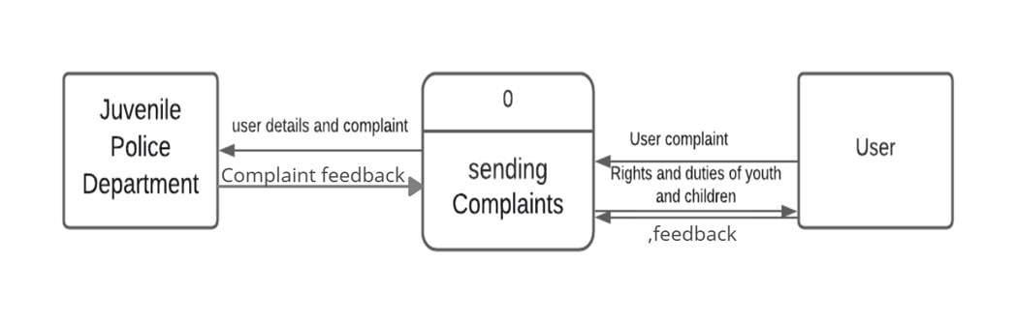

**1.6 – Literature Review**

A – Massachusetts Juvenile Police System **Introduction:** 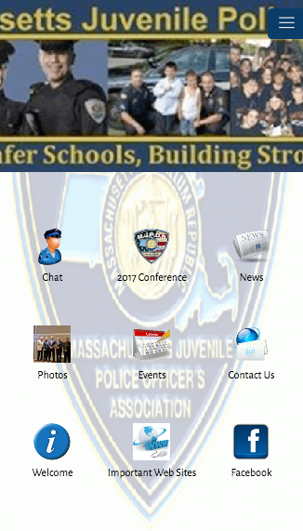

This system allows other police, school administrators and other professionals that work with students to communicate together, as the Massachusetts Juvenile Police Officers Association has been in existence for a little over 50 years and has served also New England to keep students safer.

**Overview of the System:**

This system provides quite a bit of similarities with the Juvenile system we wish to design, Atfaulna, as it’s also a free app intended to bring adults, children and the people who could benefit from help regarding this topic in a way such that the System offers the following:

A – Contact Information

B – Chat/Report to the local police department

C – Important Sites/References

D – New & Updates for the user

The MJPS system offers basic, easy to access and navigate system as any simple, well-made Juvenile-Related system or application should have

B – Juvenile & Family Court Jrnl **Introduction:** 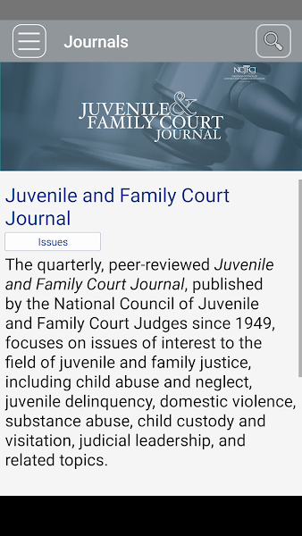

This system was published by Wiley’s Publishing, based on the journal “Juvenile & Family Court Journal” by the National Council of Juveniles & Family Course as it has been peer-reviewed since 1949. It focuses on the field issues that include: abuse, neglect, juvenile delinquency, & domestic violence, and thus resulting in making a system that’s directed to help raise awareness & report such issues.

**Overview of the System:**

The system was made with a basic design that only goes as far to act as a journal.

Juvenile & Family Court Journal brings the latest research and information on the best practices concerning issues affecting children & families, by giving the user free access to some of its content, however access to some specific content on this application is subscription based, consists of monthly to yearly subscriptions.

Features this system has:

A – Save articles easily to be read offline or online

B – Full screen figure & table viewer

C – Share articles or figures via link OR email

This system is only made available to users on iOS devices

C – InfoVNS 

**Introduction:**

Made by CSI Technology Group, this system is similar to our design in protecting the confidential juvenile information will be serving as one of this, & our program’s key feature, as it is a free program helps victims or witness report & receive information immediately regarding whichever case they have reported.

**Overview of the System:**

A system made with the intent to service the people who are in involved in the Criminal Justice System, after the registration process the user will be having a list of services available to them which mainly real-time monitoring of the report they made through this system, along with a couple of other key features including:

A – Universal mobile access to track the case anytime & anywhere

B – Mentioned in the Introduction, The protection of the juvenile’s Information

C – Data encryption & secure data

This system is only made available to users on iOS devices, to help people in the United States.

D – Criminal Justice Criminology Books

 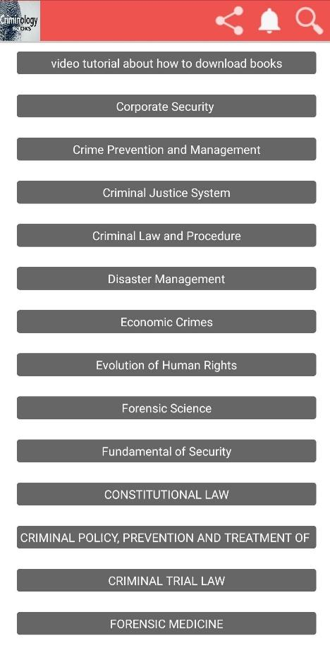

**Introduction:**

This android application made by Tech Explorer differs that than the other systems referenced considering it is not made for the intent of reporting, or to resort to when in need of emergency help, however it acts as a reference or a type of dictionary for people interested in the topic.

**Overview of the System:**

This system includes a long variety of books & references for people with an interest, or leaning to learn more information regarding the criminal justice system, specially people who happen / wish to study such topics in the future for their bachelors or masters, however in regards to our application it has multiple books to reference or learn move about in terms of Juvenile Delinquency, Juvenile Justice, & Victimology

**1.7 - Challenges**

Environmental challenges: Due to the current state of the world and the spread of COVID-19, it will be difficult to meet up with the team to work effectively and efficiently on the project and communicate our ideas in a more natural manner, as

Time challenges: As university students, we will be given assignments, quizzes, exams, and other projects to work on throughout the semester, so time will be constrained and might lead to some delays in our work if it isn’t managed properly, leading to quite a lot of stress on the student(s), specially during a pandemic.

Communication challenges: Since we are working with an external entity (Juvenile Police Unit), we could face a set of communication challenges when it comes to reaching out to said entity and their availability and ability to give us the adequate information we need to work on the application.

Technical challenges: Like any software-based project, we could face bugs, downtime, performance and security issues, in addition to adapting to a new way of designing applications by using new, more popular methods such as Flutter.

Finding study/research partners: Naturally during online classes it’s hard to communicate with other students, & not having the ability to talk to them face-to-face makes finding partners with the right synergy & flow as you a more tedious task, as finding such partner plays an important role in all working parties of being communicative & on the same page at all times.

Resources: Students usually have much more limited resources than even the smallest of businesses, in that aspect they might be forced to resort to limiting themselves a lot more, making it so they may not fully follow up with some of the software aspects that they had initially planned.

1.8 Projection

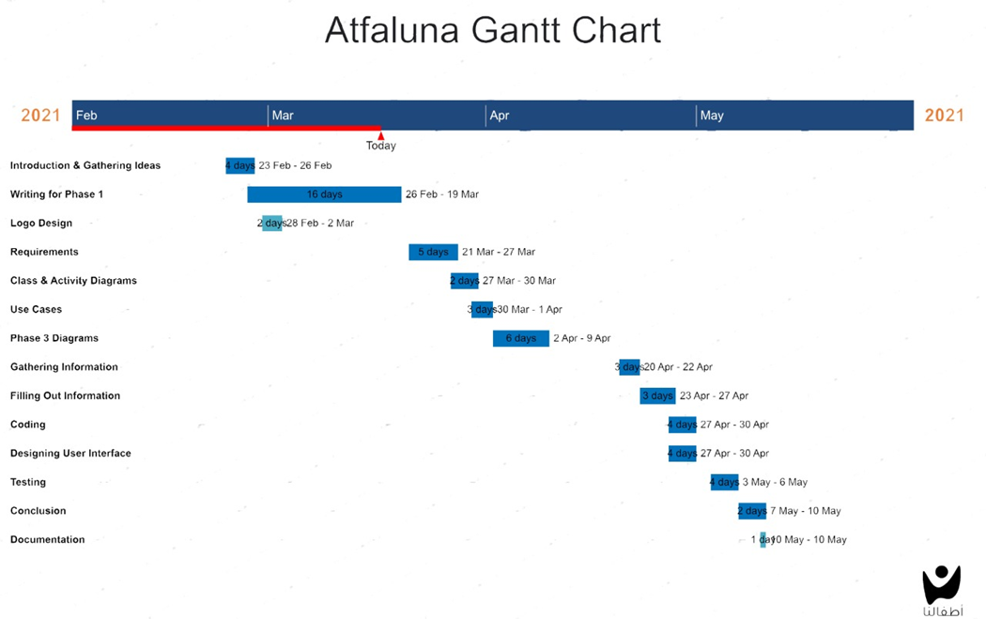

**2.1. Functional Requirements**

|  |  |  |  |
| --- | --- | --- | --- |
| **Requirement ID** | **Requirement Name** | **Requirement Detail** | **Priority** |
| FR1 | Input User Information | Taking SSN , phone number and email for the user. | Essential |
| FR2 | Report a problem | Receiving information about the complaint such as name, residential area, main event (The problem) and when it occurs. | Essential |
| FR3 | Awareness and rights presentations | Presenting a collection of slides or pictures that give the user more Awareness for young teens and their rights in community. | Optional |

FR1: To provide the juvenile police with sufficient information about the owner of the problem, to prevent the occurrence of fake reports, to send a report when the problem is resolved to the user.

FR2: To make sure that problem won’t occurs again and to know how is the person who did that event so the juvenile police can handle the case.

FR3: To reach a generation that knows its full rights and has enough awareness to build effective generations in society.

**2.2. Non-Functional Requirements**

|  |  |
| --- | --- |
| **Requirement ID** | **Requirement Name** |
| NFR1 | Information Prioritization |
| NFR2 | Accessibility |
| NFR3 | Data Integrity |
| NFR4 | Performance |
| NFR5 | Security |
| NFR6 | Platform compatibility |

NFR1 –Information Prioritization: Atfaluna attempts to minimize the usage of vertical scrolling to make everything accessible to people whose devices may suffer from issues in doing so, important links or information will be placed within instant access of the users once the application is launched

NFR2 - Accessibility: To make sure the application is accessible to everyone, the Atfaluna application will aim to follow some of the WCAG guidelines in order for people with disabilities when it comes to accessing the web (such as visual or auditory)

NFR3 – Data Integrity: To reach a generation that knows its full rights and has enough awareness to build effective generations in society.

NFR4 – Performance: A big focus on the developing Atfaluna will be attempting to optimize the program to the fullest & make sure it will perform well & as smooth as possible on all devices it is compatible with specially the older devices

NFR5 – Security: Each user will have their information kept safe by using encryption & saved into the police system where only the agent or administrators will only have important access such as the user’s information & IP address

NFR8 – Platform Compatibility:

**2.3. Class Diagram**

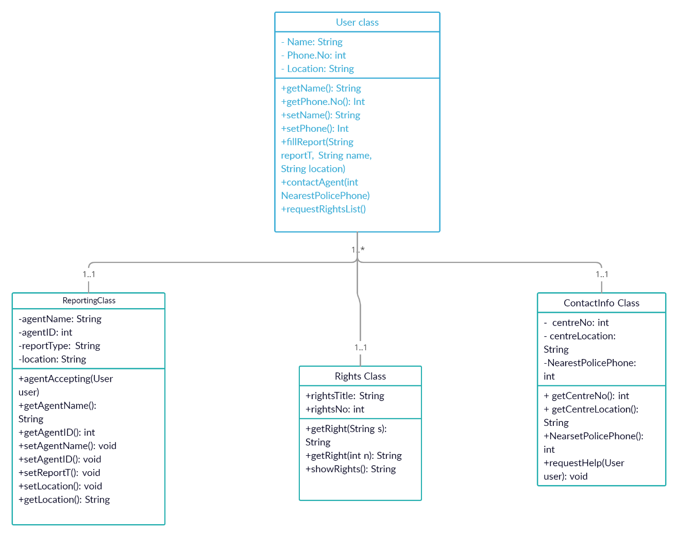

**2.4** Use case: View Rights and Duties

Actor: User, System

Purpose: Present the user with rights and duties of juveniles with information about each one.

Overview:

The use case starts when the user opens the application. The main page shows the rights, and there’s another button for the duties page. The user can tap on any right or duty and get more information about either.

Type: essential

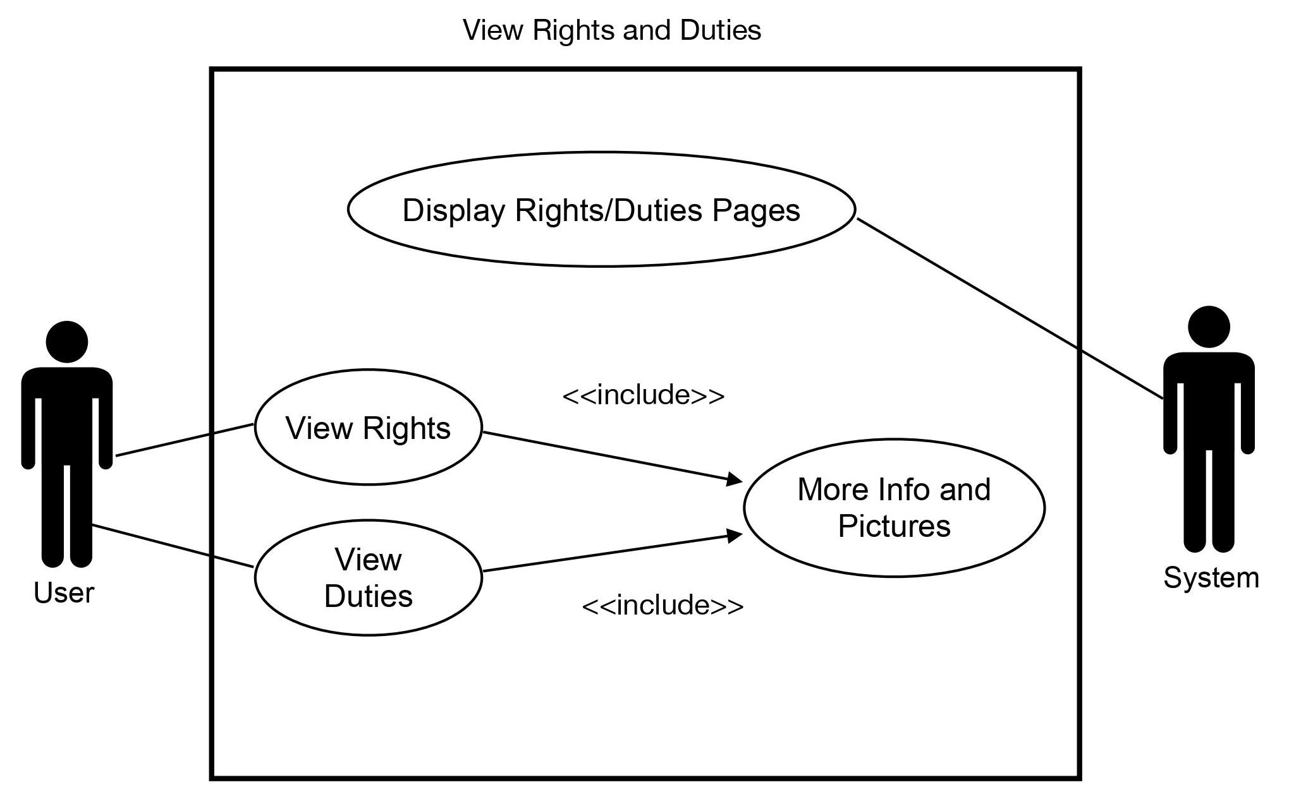

Use case: Report Problem

Actor: User, Juvenile Police Unit, System

Purpose: Report a problem or incident to the Juvenile Police Unit

Overview:

The use case starts when the user taps the Report tab on the application. The system requests the user’s info (National ID, Email, Phone Number) and verifies it. After verification, it requests a description of the problem and an option to send it. When the user is done writing the description, it is sent to the Juvenile Police Unit, which will follow up on the problem and hopefully address it.

Type: optional

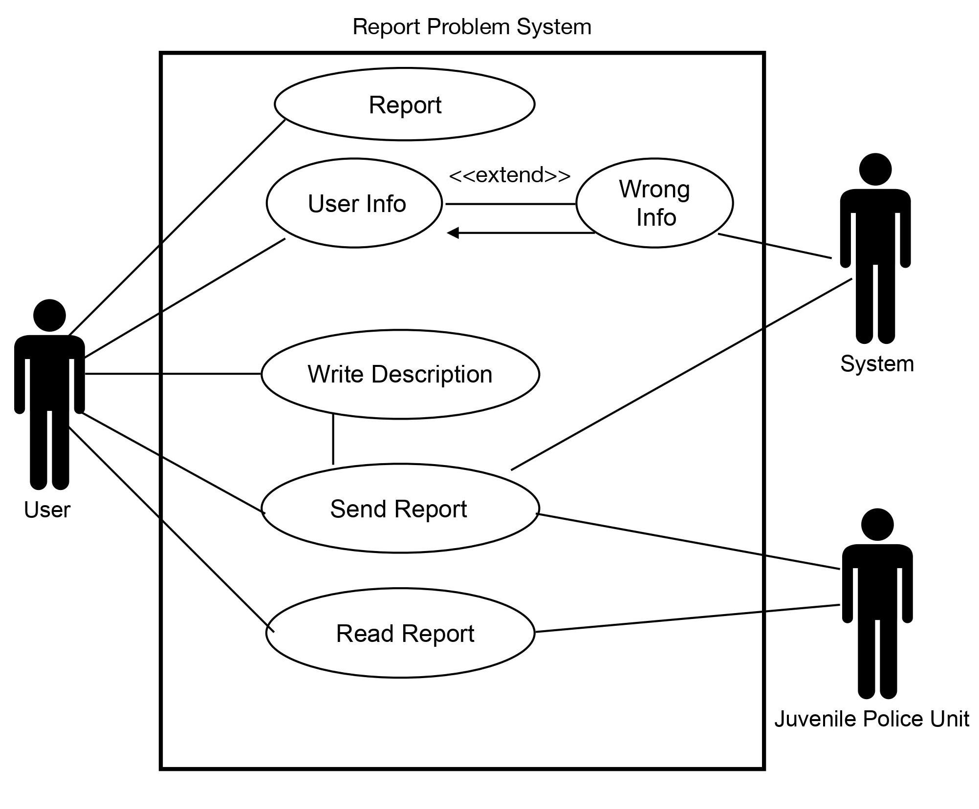

Use case: Notification System

Actor: User, Juvenile Police Unit, System

Purpose: Alert the user with updates about an incident or problem they reported.

Overview:

The use case starts when the Juvenile Police Unit has an update to share about an incident a particular user has reported. The Juvenile Police Unit writes a report about the incident and sends it to the user as a notification.

Type: optional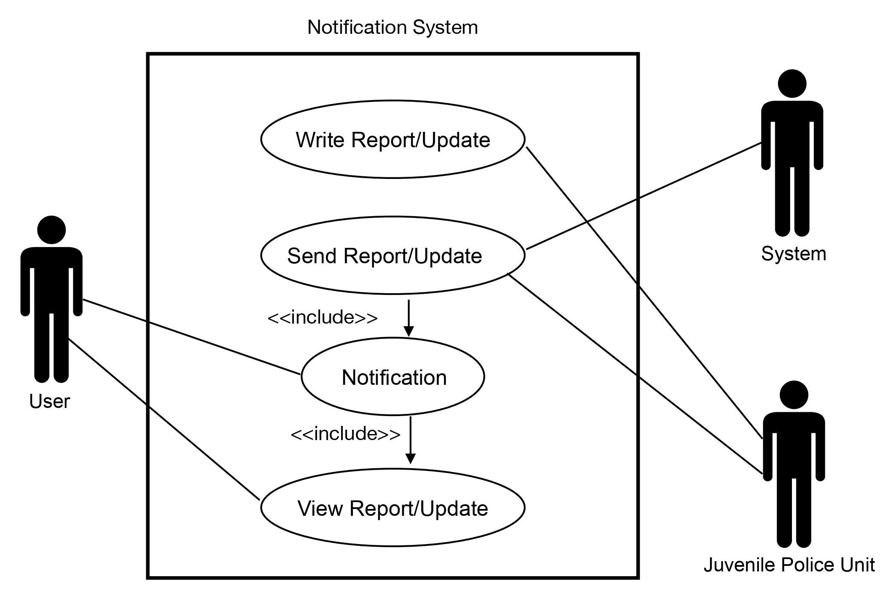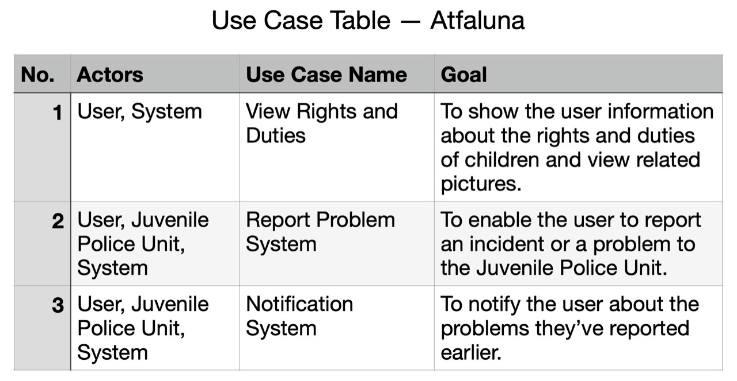

**2.5 Activity Diagram:**

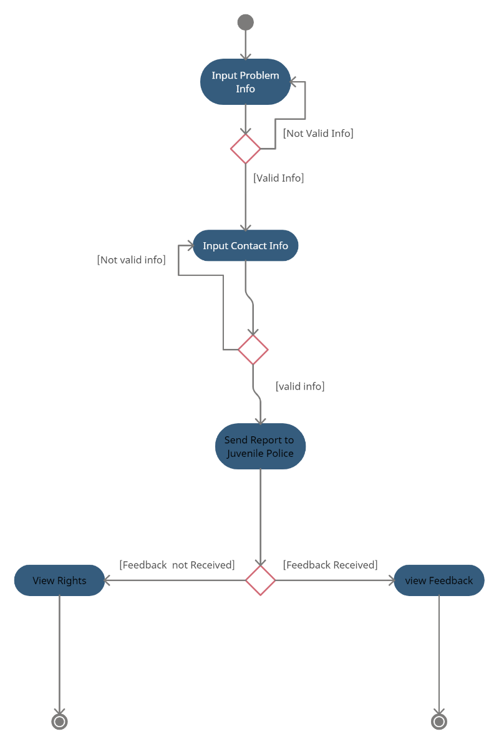

Atfaluna App will ask user for problem info and check if its valid or not if not the app will ask the user again to input if it is valid will take contact info if its valid the will send the report (problem Form) if not valid will take input again, then the app will check if feedback is received will view the feedback or if not the app will view rights

And exit till the feedback received.

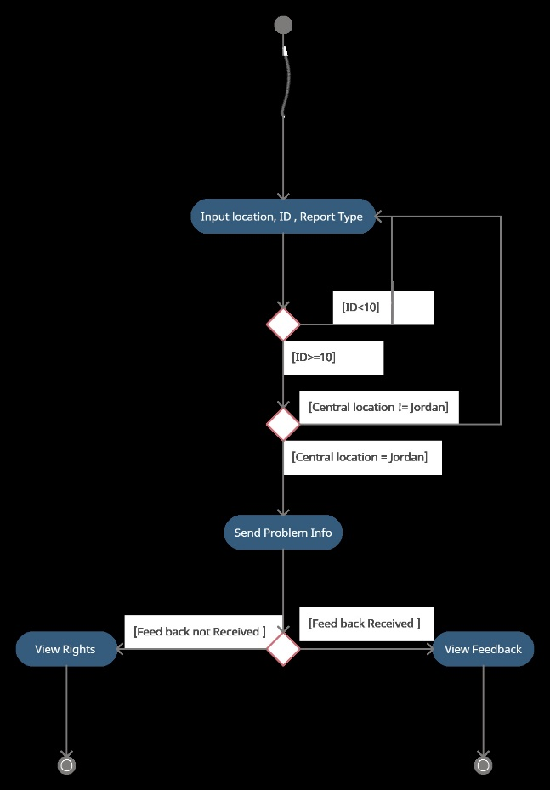

The App will ask the user to input location (where problem happened if not in Jordan will ask to input again), ID (SSN if the length of SSN is larger than 10 will ask to input again), Report type (there will be option like radio buttons so no validation is needed) then the problem form will be filled problem will be send with the info in form and wait for feedback if it’s received will view Feedback else will view the rights and wait till feedback is received.

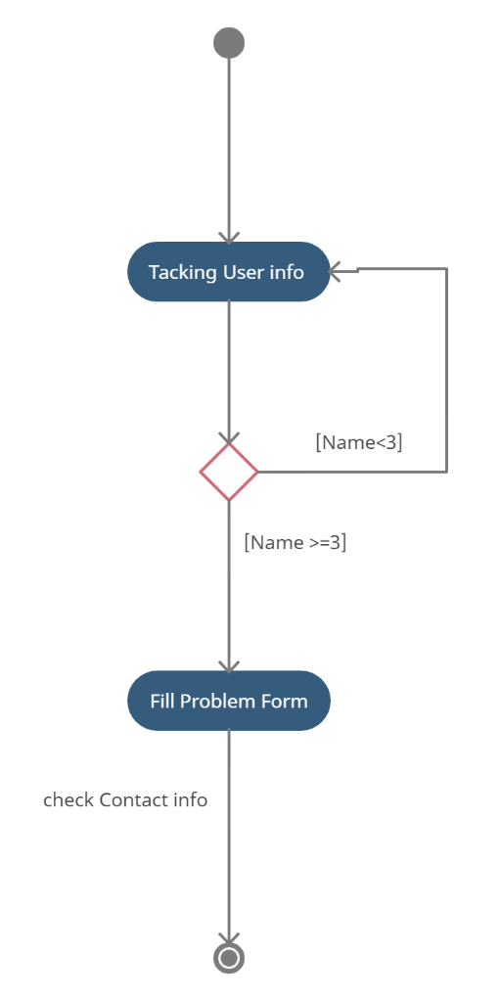

The app will take user info like Name and check if the length of the name is less than 3 digits if it’s it will ask the user to input info again else it will fill the problem form with the information and then will go to the other figure to check contact info.

* 1. **Sequence Diagram**

Example (1): Filing a Report

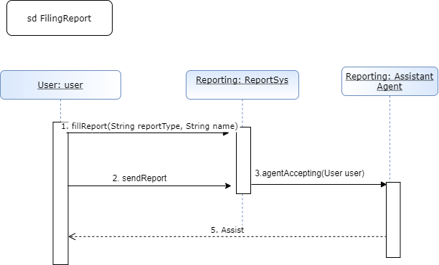

Example (2): Requesting Agent Assistance

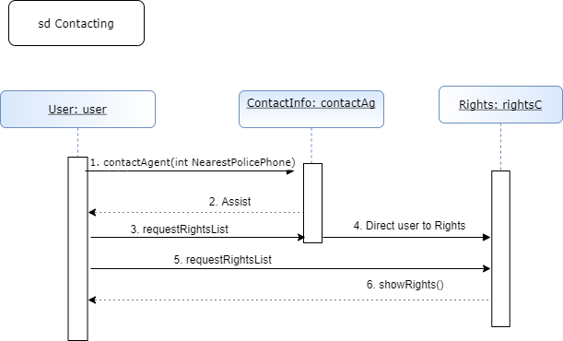

Example (3): Reporting Help

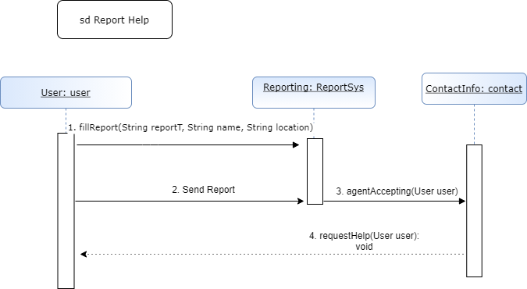

* 1. **State Diagram:**

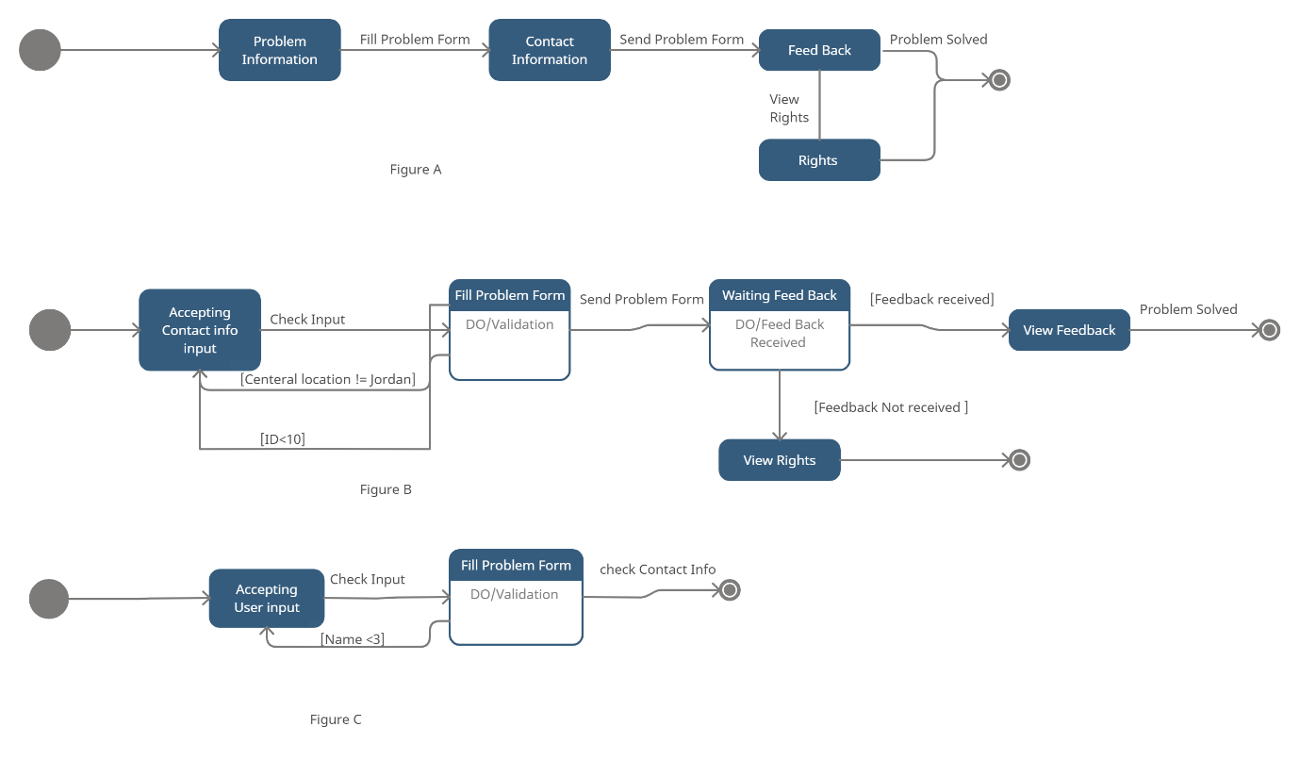

Figure A:

When The App starts First thing it takes the problem Information (login) and Fill it into the Problem Form (which contains All the Problem information and User info) then it will ask user to input his info so that the police can contact him then the App Send the Form to The police and Wait for Feedback or The user can view youth Rights.

Figure B:

The App will ask the user to input contact info (information about the problem like where the problem happen the id of the person who had the problem which is the SSN (Password)) then the App will check the information if it’s valid or not if not the App will make the user do input again if it is valid the app will wait till Feedback is received from police then the app will view the Feedback or the user can view Rights and exit until feedback is received.

Figure C:

After taking User Info the App will check if the info is valid or not (if name length is less than 3 not valid) and let the user try input info again else if its valid the problem Form will be sent to police.

**3.3 User interfaces:**

**Rights & Duties pages**

Showing the rights and duties of children with the ability to

learn more and see pictures for each point.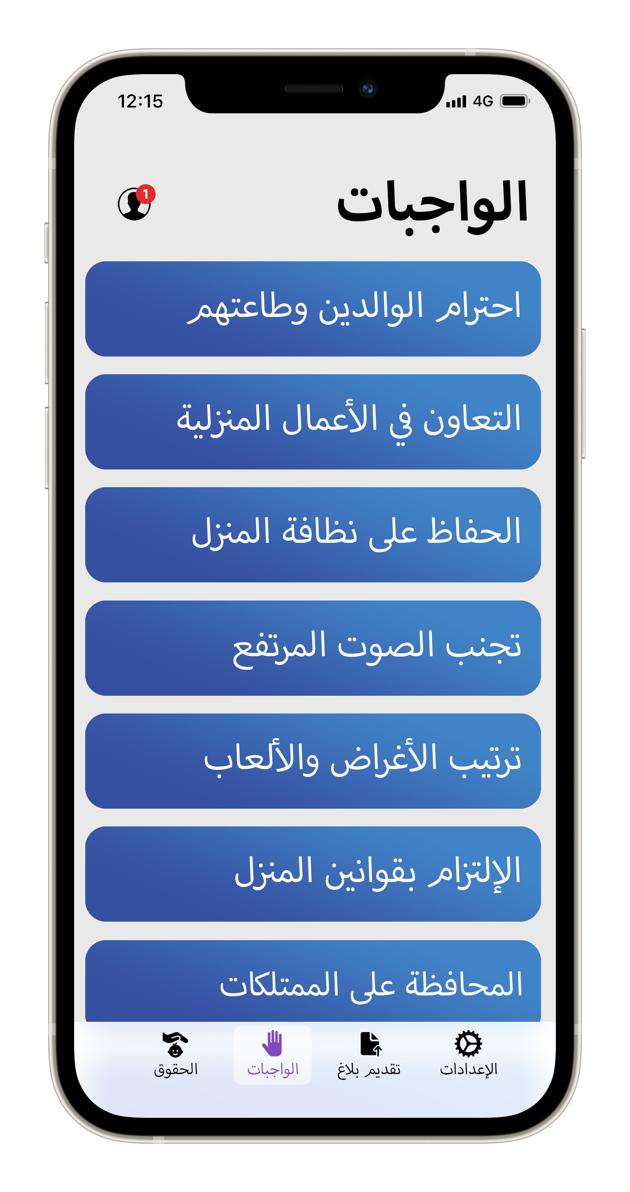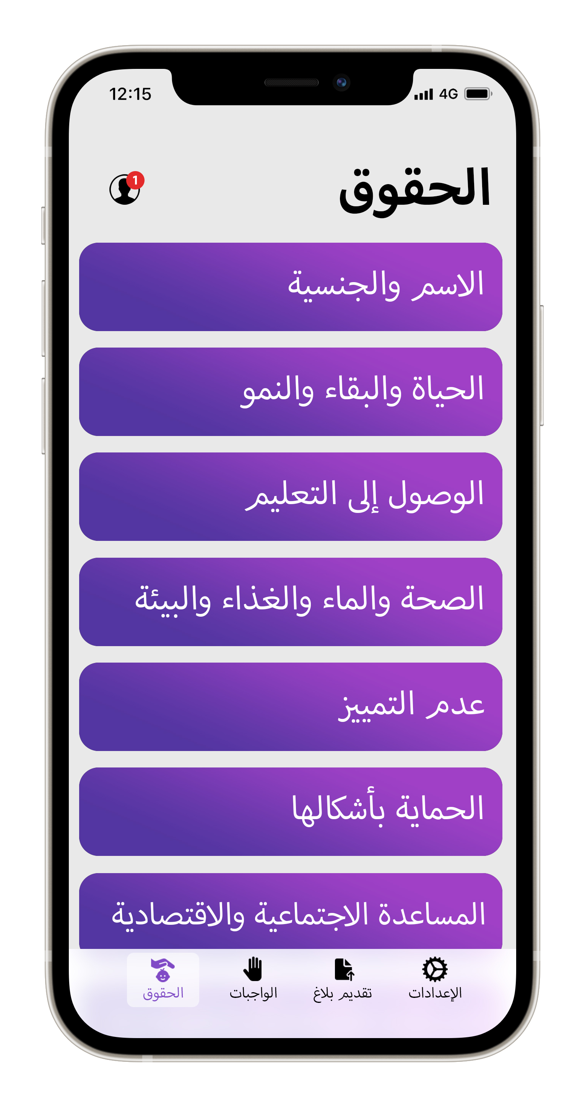

Expanded page from “Rights” section

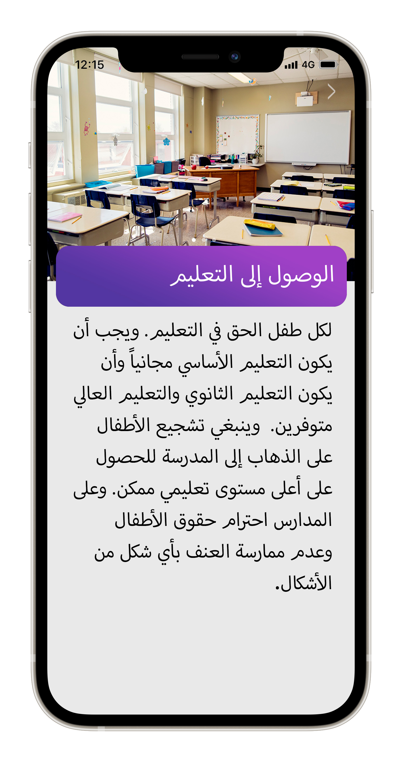

**Report page**

Allows the user to easily report an incident or a problem to the Juvenile Police Department.

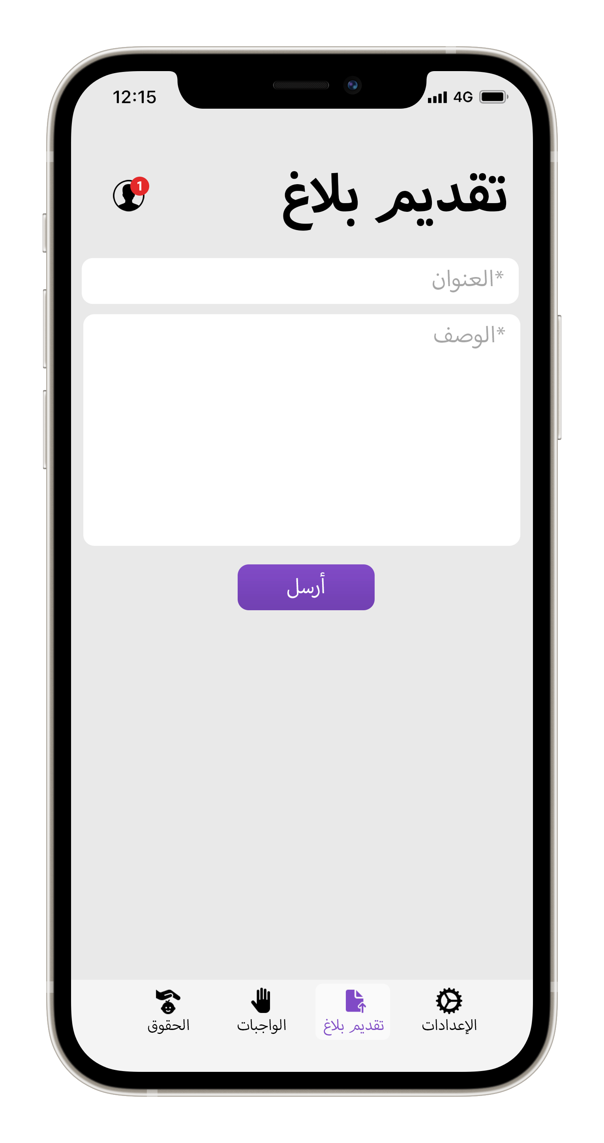

**User page**

Allows users to create an account, sign in, check their notifications, edit their information, and sign out.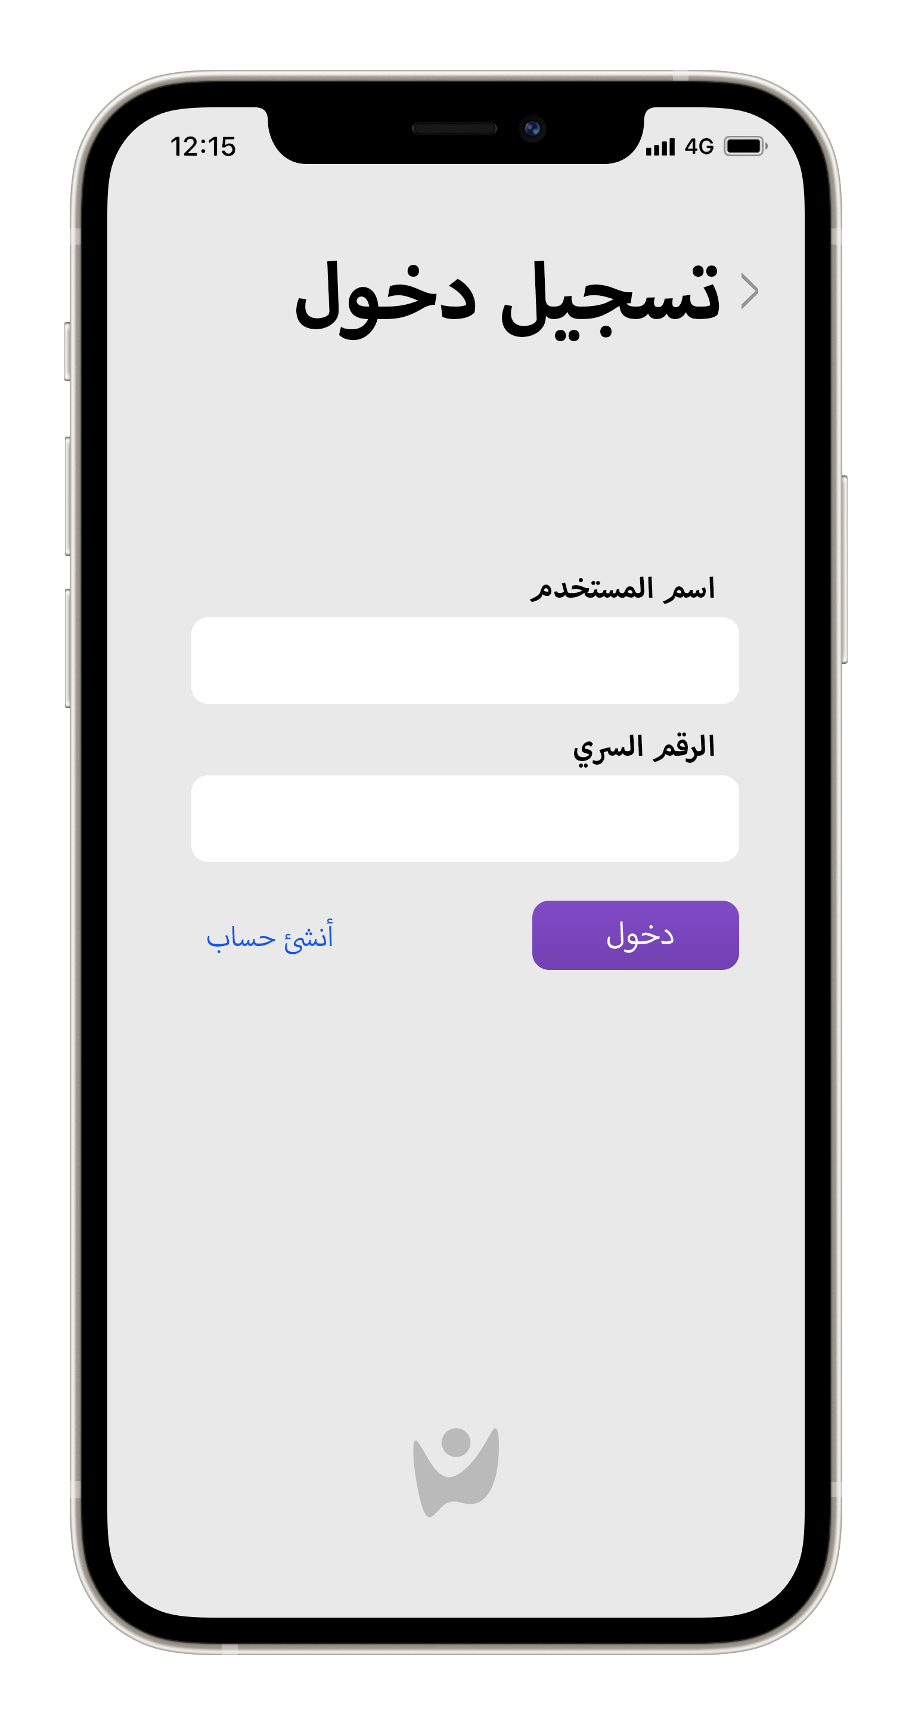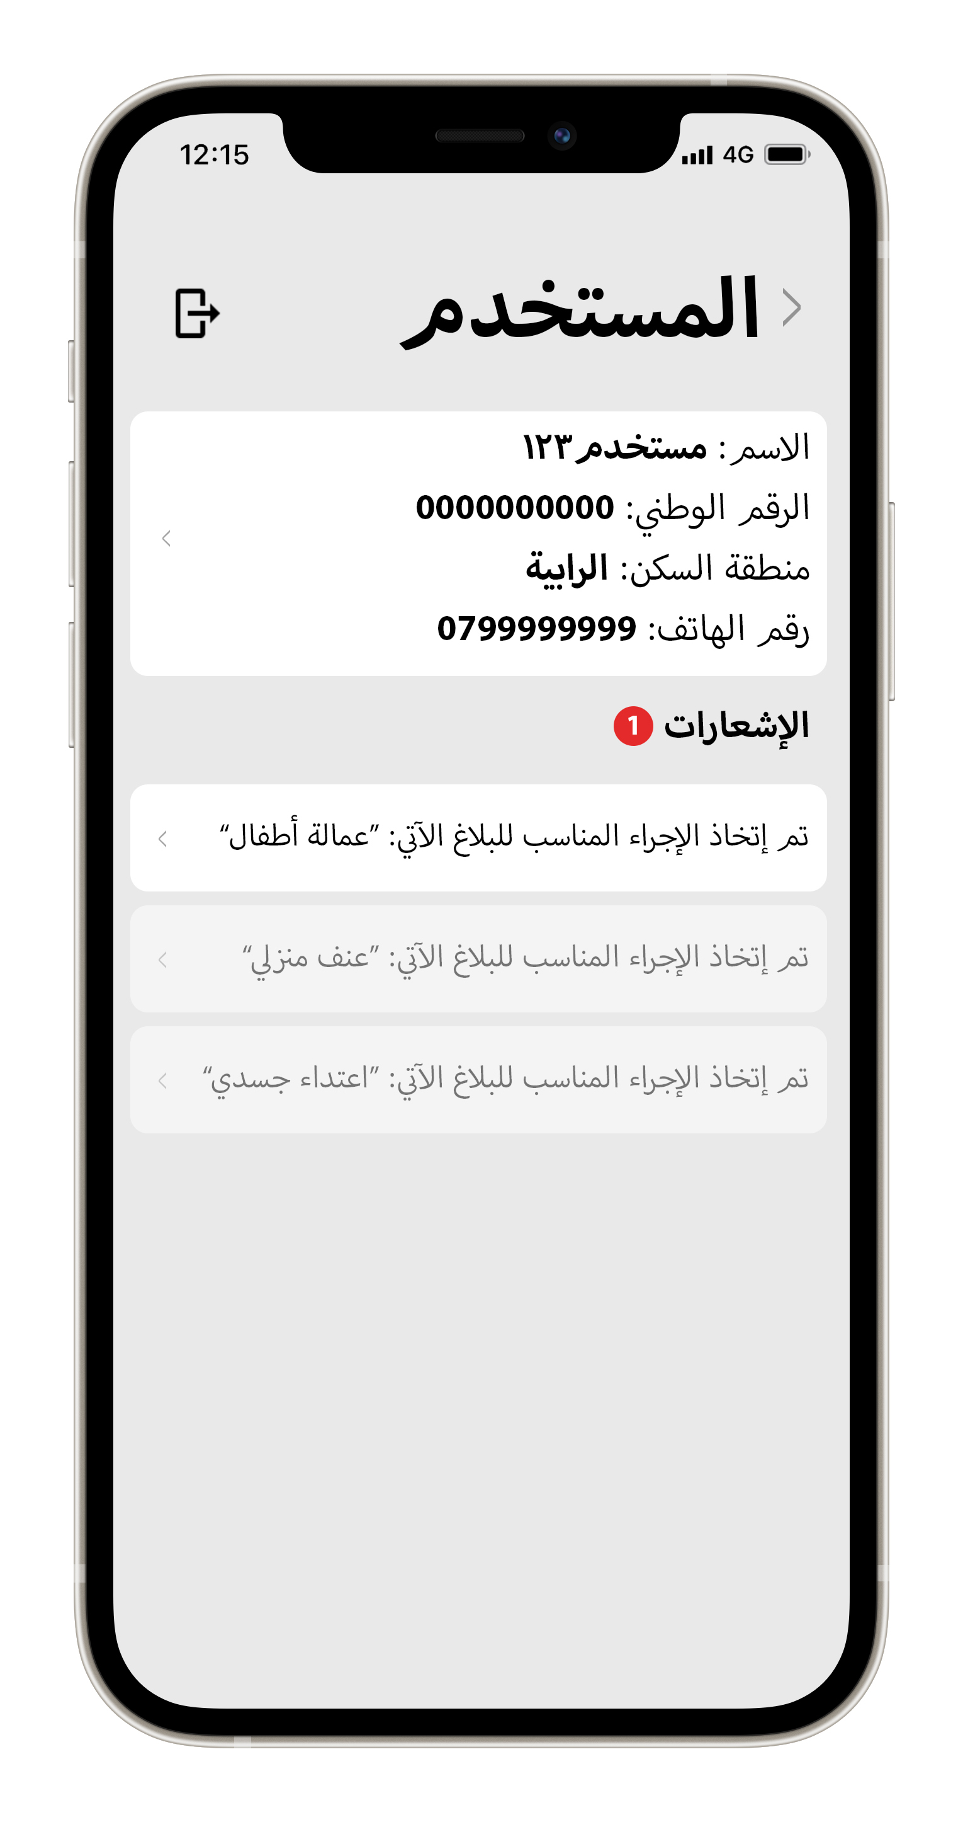

**3.4 Future work:**

In the future, we plan on adding more useful features, such as an AI system that automatically categorizes the type of the report using keywords from the description of the user’s report (violence, child labor, attack etc.), a chatting system that enables users to ask about a specific problem, a feedback tab to report bugs and issues or suggest a feature to developers, a tab that shows success stories to encourage more reporting of juvenile-related issues and raise awareness about such issues, and an events tab to show upcoming events related to these issues.

Alongside adding more features, we would like to reach even more people using TV, social media, billboard advertisements, a dedicated website for desktop use, and online and face-to-face events.